Examples of design patterns present in this project:

Adapter:

Used to transform from waypoint positions to marker models and back. Also using through DTOs mappers.  
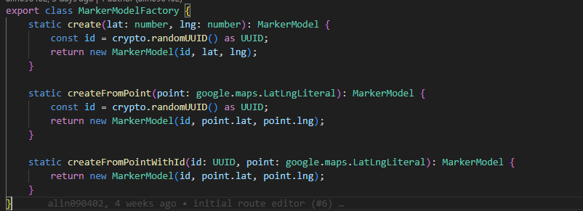

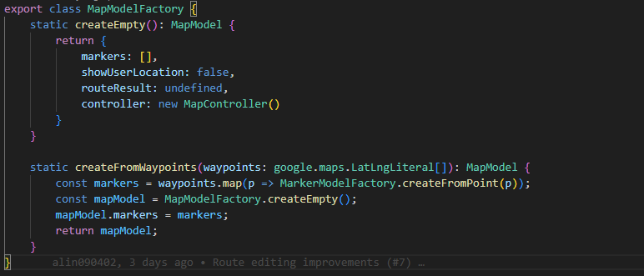

Mediator pattern:

The MapStore class function for a mediator for mapModel updates, action handling through controllers and ui component updates.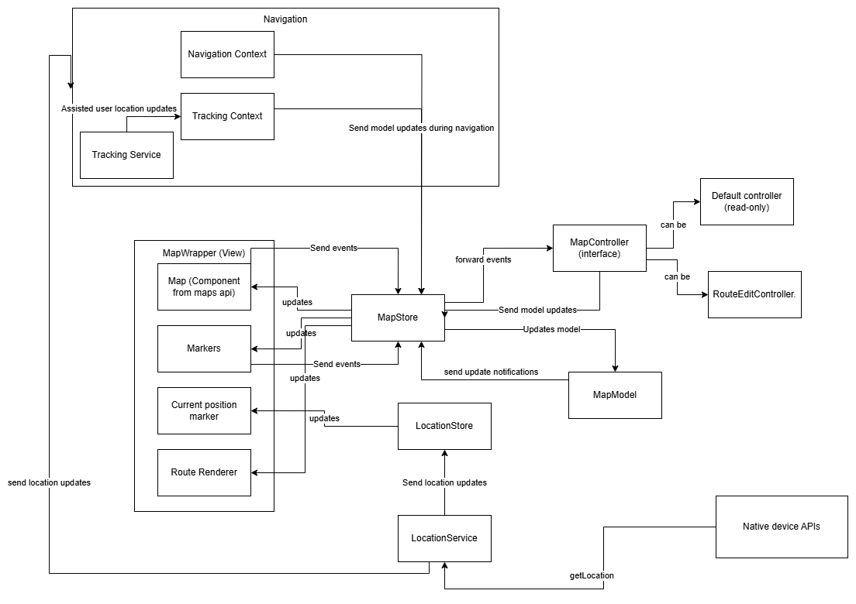

Observer:

User for location updates that can come at any moment. The classes that need location updates subscribe to the LocationStore and he will notify all observers when the location updates.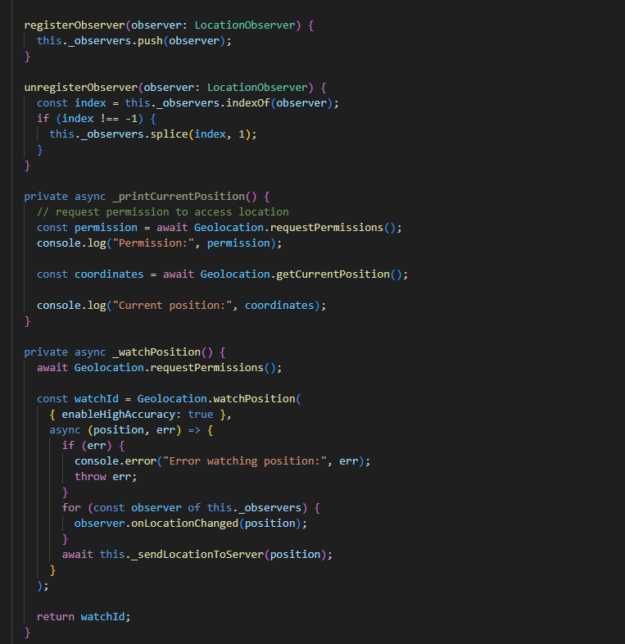

State:

Used to adjust the behaviour during the NavigationContext. If the user is lost we need to reroute him to the main saved route.

